Practical 23:

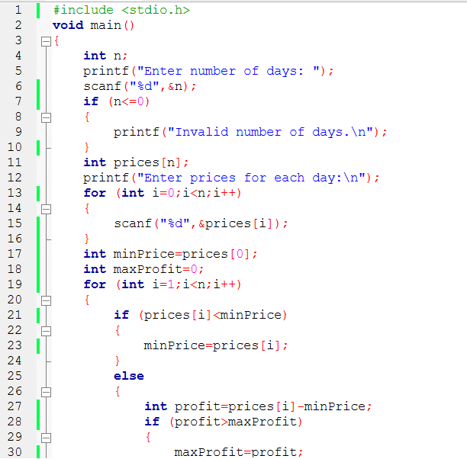

23-i:

23-ii:

